Question-1

Question-2

Question- 3

Question- 4

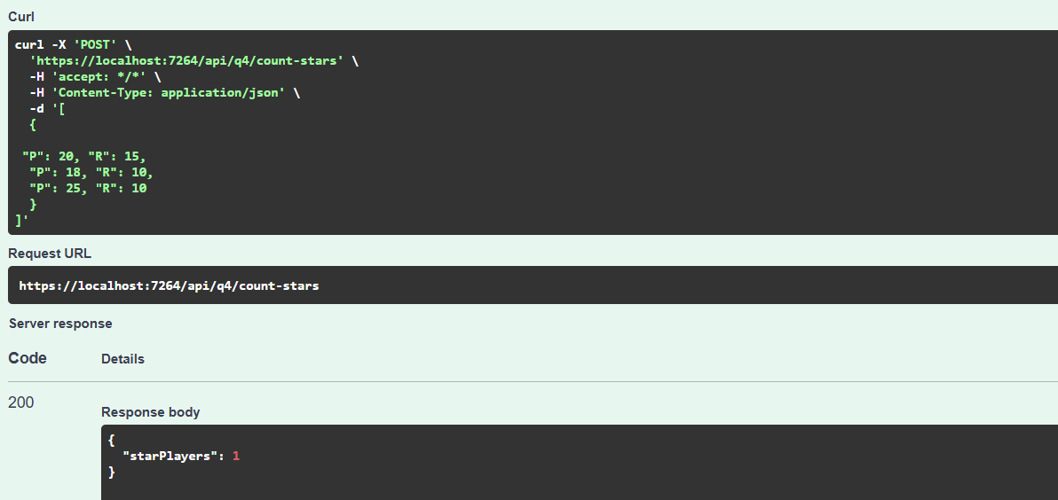

Question- 5

